**My Creative Coding Project.**

* ***Inspiration from other artists / projects…***

**Created by: Galka Max**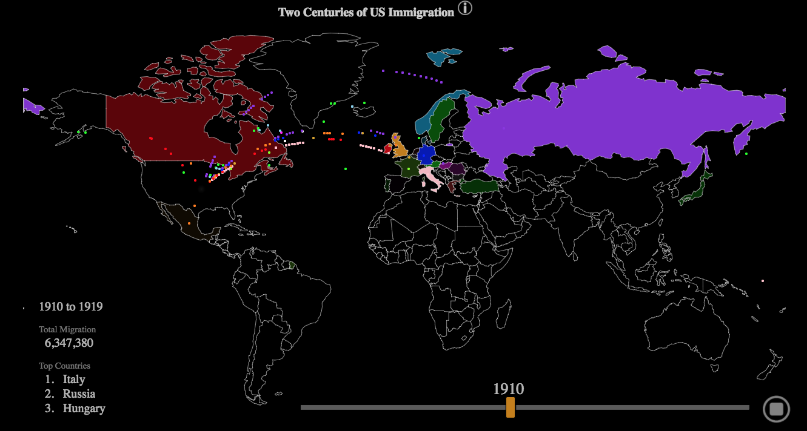

*This project uses colour coordinated spheres to show immigration to the US from various countries. The movement of the spheres from country to country in a formatted manner is one of the inspirations behind the motion of my project.*

**Created by: Muyueh Lee**

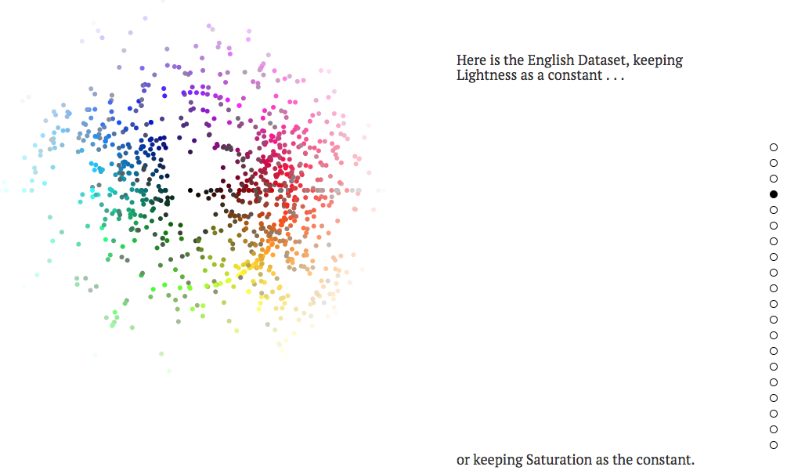

*This project aims to show off the difference in colour representation for China and the United Kingdom.*

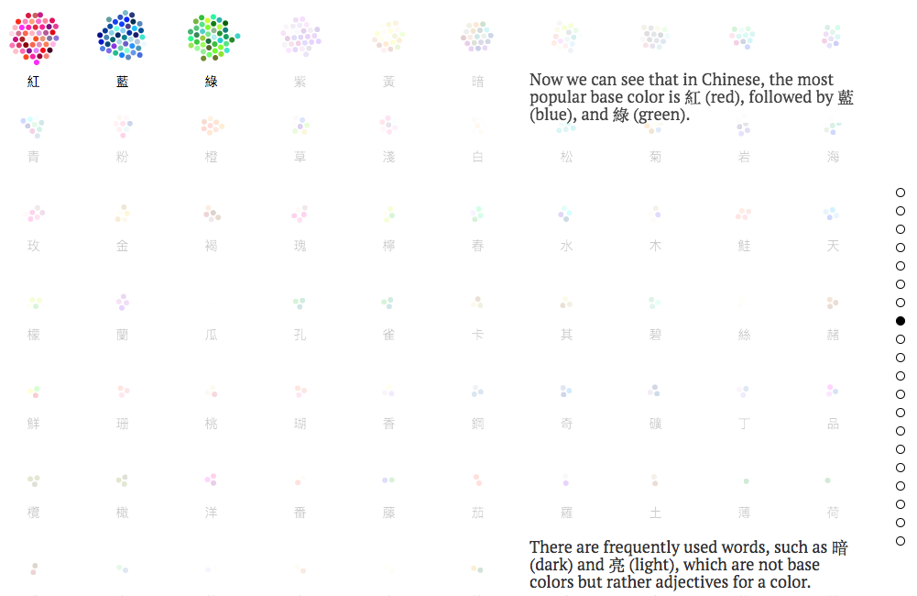

*Similar to the project above, I took inspiration from the movement of the spheres on the page as you progress through the project. The use of colours would be something I would like to add to my project in the future.*

* ***Old NYC***

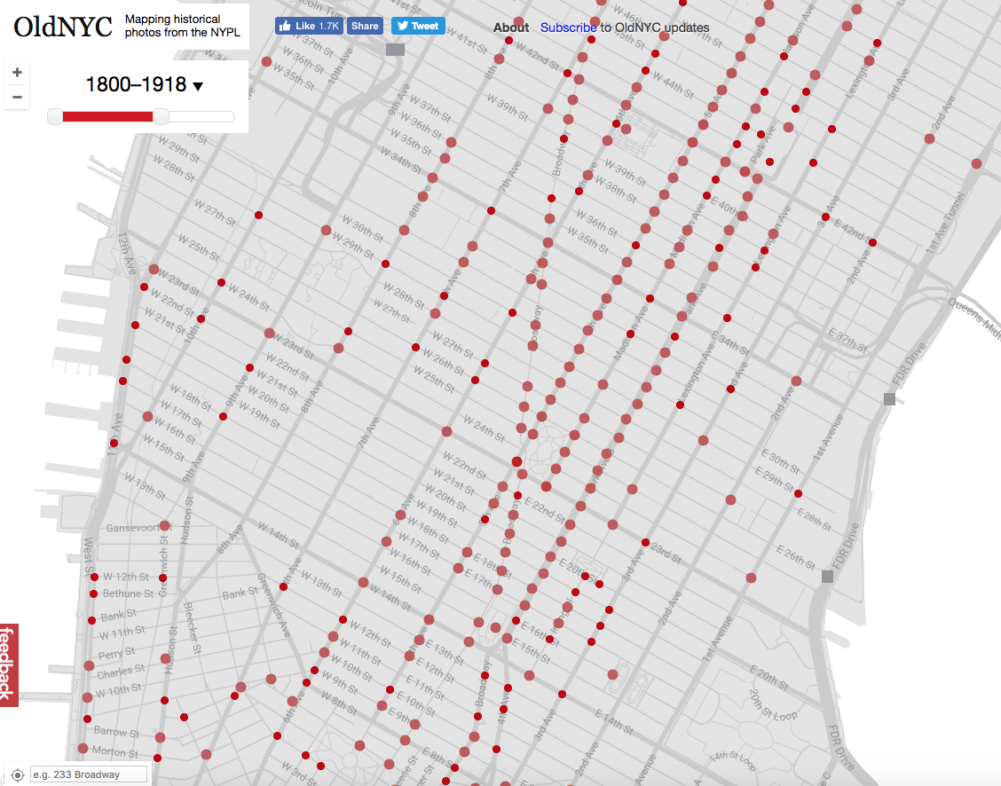

*Within this project locations around NYC have unique photos tied to locations on a map that are represented by spheres. This was the project that made me want to use spheres to convey data to the user.*

* ***My process and Issues***

*At the beginning of the project my initial idea was to have data displayed as a bar chart that would be animated and vary in size based of data from the API.*

*The bars would vary in size and colour based off of the value ‘remaining_life_expectancy’ extracted from the API, the lower the value, the smaller the bar.*

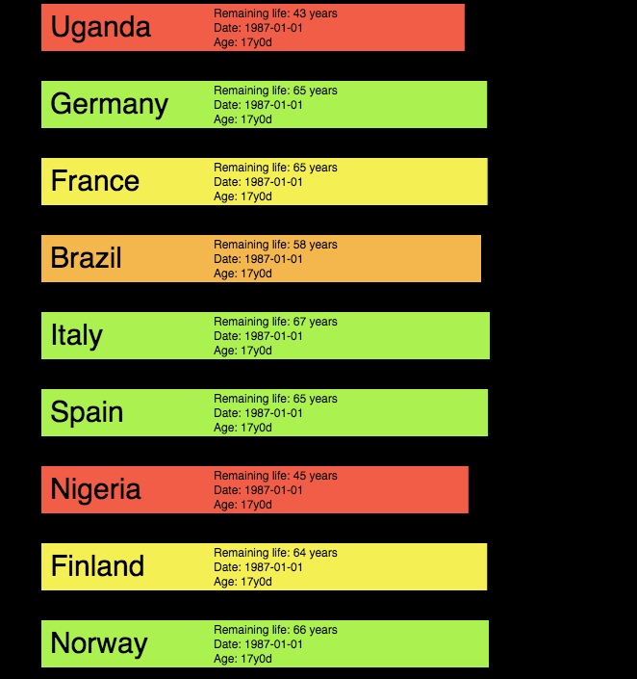

*I then decided to scrap this project. I wanted to make something that was leaning more toward being abstract. I took inspiration from things called ‘Orbs’ which are small reflections / artifacts of light in photos that can be caused by rain drops when a camera uses a flash.*

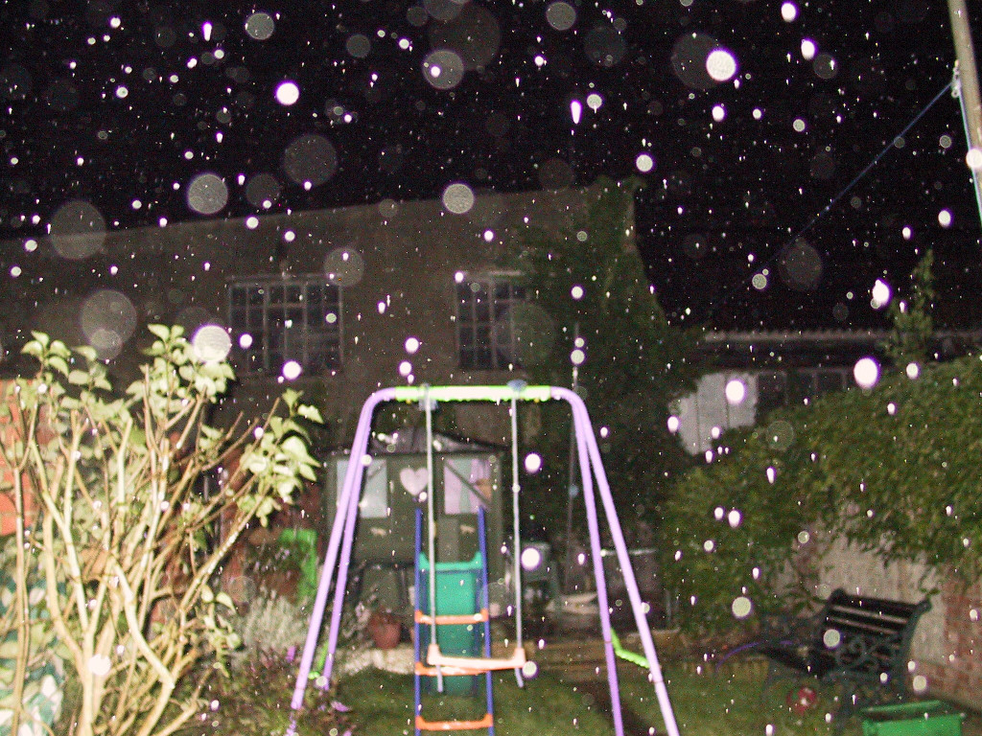

*From there, I began creating the animation for the random bouncing orbs. I then changed the orbs movement to reflect and follow one another (2 pairs reflecting one another making a total of 4 balls for 1). The number of orbs on the screen at 1 time is equal the value of ‘remaining life expectancy’ multiplied by ‘4’ . I then began adding the information to the canvas that I wanted the user to see such as age and remaining life expectancy. Finally I added some user interaction via a drop down box. This allows the user to change the age value, resulting in a change to the ‘RLE’. It is then displayed to the user via text and a small outburst of spheres, representing the new ‘RLE’.*

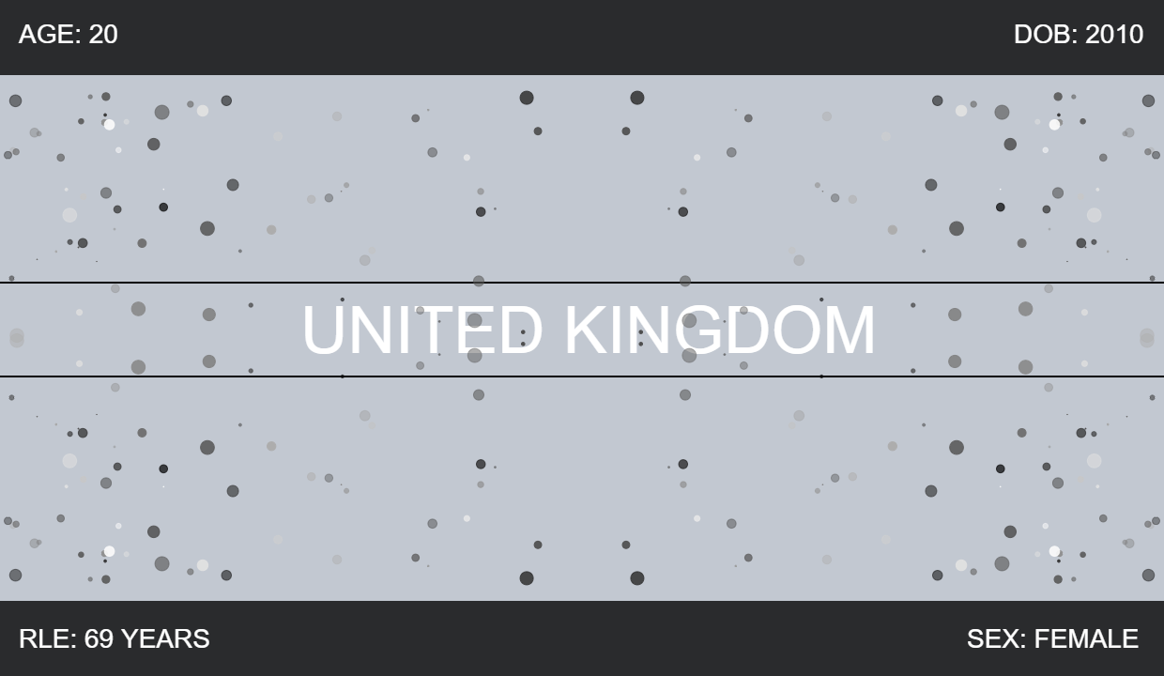

**Issues I faced and future upgrades**

**I would like to make...**

*The main issue was creating user interaction. I had trouble with trying to add a text input field, it would not allow a user to type within the field. So after spending a while trying to fix the issue I switched to a drop down box as a form of user interaction.*

*Upgrades I would make to my project would be by using the API data to control things like speed and colour of the orbs. I would change the colour of the orbs based off of the value of ‘remaining life expectancy’. Furthermore, I would like this to correlate with the speed of the ‘orbs’. Finally, I would like to add more forms of interaction to allow the user to further query the API.*

**Images Of My Project.**

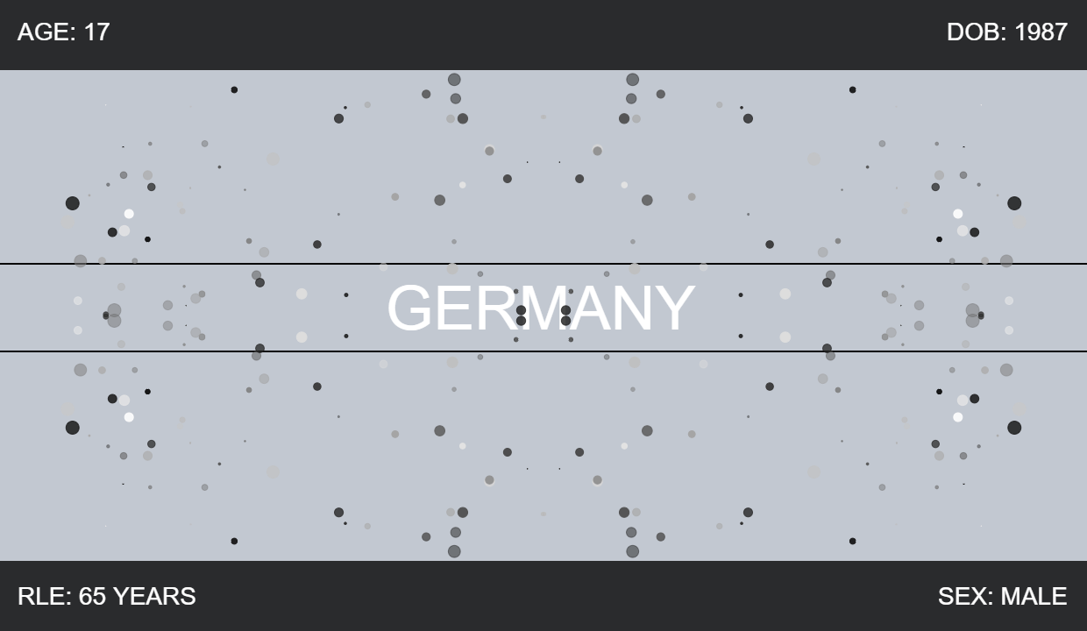

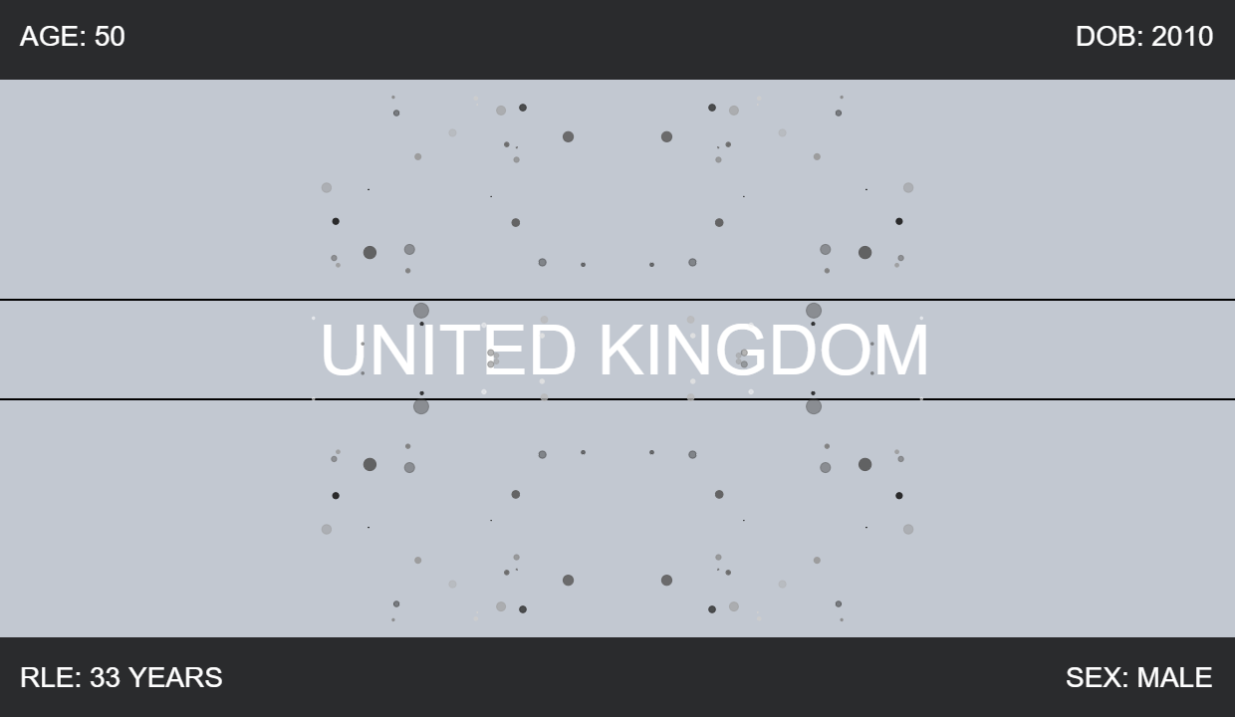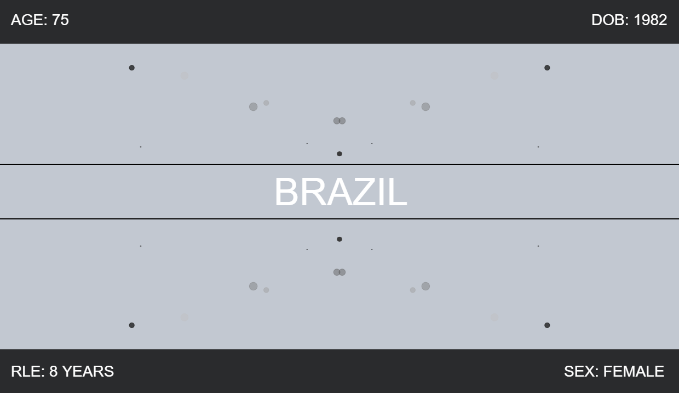



**My GitHub Page**

[*https://thomaskerslake.github.io/*](https://thomaskerslake.github.io/)

**References**

Two Centuries of US Immigration Visualized -- Metrocosm. 2018. Two Centuries of US Immigration Visualized -- Metrocosm. [ONLINE] Available at: <http://metrocosm.com/us-immigration-history-map.html>.

Green Honey. 2018. Green Honey. [ONLINE] Available at: <http://muyueh.com/greenhoney/?es_p=1228877>.

OldNYC. 2018. OldNYC: Mapping Historical Photographs of New York City. [ONLINE] Available at: <https://www.oldnyc.org/>.

Orb (optics) - Wikipedia. 2018. Orb (optics) - Wikipedia. [ONLINE] Available at: <https://en.wikipedia.org/wiki/Orb_(optics)>.